JAVA-2 ASSIGNMENT

Ques 1: Implement a banking system using java. Create 3 sub class of Bank : SBI,BOI,ICICI

Classes should have attributes like Name, headofficeAddress, chairmanName, branchCount, fdInterestRate, personalLoanInterestRate, homeLoanInterestRate. All 3 should have following methods:

* add getters and setters for the fields
* print details of every bank (override toString)

Bank:

abstract class bank

{

public String Name,headofficeAddress, chairmanName;

public int branchCount;

public float fdInterestRate, personalLoanInterestRate, homeLoanInterestRate;

//constructor

// public bank(String name,String headofficeAddress, String chairmanName,int branchCount, float fdInterestRate,float personalLoanInterestRate, float homeLoanInterestRate)

// {

// this.Name = name;

// this.headofficeAddress= headofficeAddress;

// this.chairmanName= chairmanName;

// this.branchCount= branchCount;

// this.fdInterestRate=fdInterestRate;

// this.personalLoanInterestRate= personalLoanInterestRate;

// this.homeLoanInterestRate=homeLoanInterestRate;

// }

//getter

public String getName() {

return Name;

}

public String getHeadofficeAddress() {

return headofficeAddress;

}

public String getChairmanName() {

return chairmanName;

}

public int getBranchCount() {

return branchCount;

}

public float getFdInterestRate() {

return fdInterestRate;

}

public float getPersonalLoanInterestRate() {

return personalLoanInterestRate;

}

public float getHomeLoanInterestRate() {

return homeLoanInterestRate;

}

public abstract void setName(String name);

public abstract void setHeadofficeAddress(String headofficeAddress);

public abstract void setChairmanName(String chairmanName);

public abstract void setBranchCount(int branchCount);

public abstract void setFdInterestRate(float fdInterestRate);

public abstract void setPersonalLoanInterestRate(float personalLoanInterestRate);

public abstract void setHomeLoanInterestRate(float homeLoanInterestRate);

}

public class SBI extends bank

{

@Override

public String getName() {

return super.getName();

}

@Override

public String getHeadofficeAddress() {

return super.getHeadofficeAddress();

}

@Override

public String getChairmanName() {

return super.getChairmanName();

}

@Override

public int getBranchCount() {

return super.getBranchCount();

}

@Override

public float getFdInterestRate() {

return super.getFdInterestRate();

}

@Override

public float getPersonalLoanInterestRate() {

return super.getPersonalLoanInterestRate();

}

@Override

public float getHomeLoanInterestRate() {

return super.getHomeLoanInterestRate();

}

@Override

public void setName(String name)

{

this.Name=name;

}

@Override

public void setHeadofficeAddress(String headofficeAddress)

{

this.headofficeAddress=headofficeAddress;

}

@Override

public void setChairmanName(String chairmanName)

{

this.chairmanName=chairmanName;

}

@Override

public void setBranchCount(int branchCount)

{

this.branchCount=branchCount;

}

@Override

public void setFdInterestRate(float fdInterestRate)

{

this.fdInterestRate=fdInterestRate;

}

@Override

public void setPersonalLoanInterestRate(float personalLoanInterestRate)

{

this.personalLoanInterestRate=personalLoanInterestRate;

}

@Override

public void setHomeLoanInterestRate(float homeLoanInterestRate)

{

this.homeLoanInterestRate=homeLoanInterestRate;

}

// public SBI(String name, String headofficeAddress, String chairmanName, int branchCount, float fdInterestRate, float personalLoanInterestRate, float homeLoanInterestRate) {

// super(name, headofficeAddress, chairmanName, branchCount, fdInterestRate, personalLoanInterestRate, homeLoanInterestRate);

//

}

ICICI bank

public class ICICI extends bank

{

@Override

public String getName() {

return super.getName();

}

@Override

public String getHeadofficeAddress() {

return super.getHeadofficeAddress();

}

@Override

public String getChairmanName() {

return super.getChairmanName();

}

@Override

public int getBranchCount() {

return super.getBranchCount();

}

@Override

public float getFdInterestRate() {

return super.getFdInterestRate();

}

@Override

public float getPersonalLoanInterestRate() {

return super.getPersonalLoanInterestRate();

}

@Override

public float getHomeLoanInterestRate() {

return super.getHomeLoanInterestRate();

}

@Override

public void setName(String name)

{

this.Name=name;

}

@Override

public void setHeadofficeAddress(String headofficeAddress)

{

this.headofficeAddress=headofficeAddress;

}

@Override

public void setChairmanName(String chairmanName)

{

this.chairmanName=chairmanName;

}

@Override

public void setBranchCount(int branchCount)

{

this.branchCount=branchCount;

}

@Override

public void setFdInterestRate(float fdInterestRate)

{

this.fdInterestRate=fdInterestRate;

}

@Override

public void setPersonalLoanInterestRate(float personalLoanInterestRate)

{

this.personalLoanInterestRate=personalLoanInterestRate;

}

@Override

public void setHomeLoanInterestRate(float homeLoanInterestRate)

{

this.homeLoanInterestRate=homeLoanInterestRate;

}

}

BOI bank

public class BOI extends bank

{

@Override

public String getName() {

return super.getName();

}

@Override

public String getHeadofficeAddress() {

return super.getHeadofficeAddress();

}

@Override

public String getChairmanName() {

return super.getChairmanName();

}

@Override

public int getBranchCount() {

return super.getBranchCount();

}

@Override

public float getFdInterestRate() {

return super.getFdInterestRate();

}

@Override

public float getPersonalLoanInterestRate() {

return super.getPersonalLoanInterestRate();

}

@Override

public float getHomeLoanInterestRate() {

return super.getHomeLoanInterestRate();

}

@Override

public void setName(String name)

{

this.Name=name;

}

@Override

public void setHeadofficeAddress(String headofficeAddress)

{

this.headofficeAddress=headofficeAddress;

}

@Override

public void setChairmanName(String chairmanName)

{

this.chairmanName=chairmanName;

}

@Override

public void setBranchCount(int branchCount)

{

this.branchCount=branchCount;

}

@Override

public void setFdInterestRate(float fdInterestRate)

{

this.fdInterestRate=fdInterestRate;

}

@Override

public void setPersonalLoanInterestRate(float personalLoanInterestRate)

{

this.personalLoanInterestRate=personalLoanInterestRate;

}

@Override

public void setHomeLoanInterestRate(float homeLoanInterestRate)

{

this.homeLoanInterestRate=homeLoanInterestRate;

}

}

MAIN:

public class Main

{

public static void main(String[] args)

{

SBI s = new SBI();

ICICI ic = new ICICI();

BOI b = new BOI();

ic.setName("riya");

ic.setChairmanName("varun");

ic.setBranchCount(2);

ic.setFdInterestRate(3.4F);

ic.setPersonalLoanInterestRate(2.0F);

ic.setHomeLoanInterestRate(4.45F);

System.*out*.println(ic.getName());

System.*out*.println(ic.getChairmanName());

System.*out*.println(ic.getBranchCount());

System.*out*.println(ic.getFdInterestRate());

System.*out*.println(ic.getPersonalLoanInterestRate());

System.*out*.println(ic.getHomeLoanInterestRate());

//for sbi bank

s.setName("shobit");

s.setChairmanName("supriya");

s.setBranchCount(5);

s.setFdInterestRate(9.4F);

s.setPersonalLoanInterestRate(7.0F);

s.setHomeLoanInterestRate(4.58F);

System.*out*.println(s.getName());

System.*out*.println(s.getChairmanName());

System.*out*.println(s.getBranchCount());

System.*out*.println(s.getFdInterestRate());

System.*out*.println(s.getPersonalLoanInterestRate());

System.*out*.println(s.getHomeLoanInterestRate());

//BOI BANK

b.setName("kunal");

b.setChairmanName("gaurav");

b.setBranchCount(5);

b.setFdInterestRate(6.7F);

b.setPersonalLoanInterestRate(4.5F);

b.setHomeLoanInterestRate(6.89F);

b.setHomeLoanInterestRate(5.6F);

System.*out*.println(b.getName());

System.*out*.println(b.getChairmanName());

System.*out*.println(b.getBranchCount());

System.*out*.println(b.getFdInterestRate());

System.*out*.println(b.getHomeLoanInterestRate());

System.*out*.println(b.getPersonalLoanInterestRate());

}

}

OUTPUT:

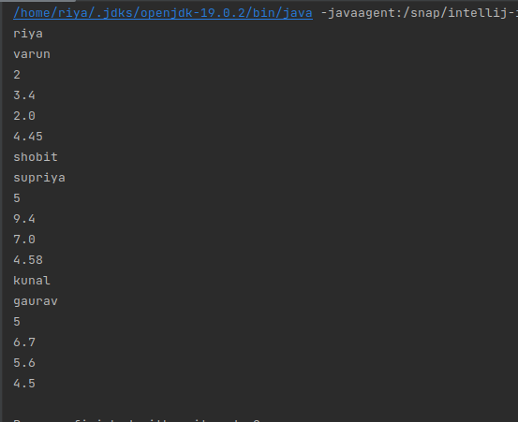

Ques 2: WAP showing try, multi-catch and finally blocks.

public class exceptionDemo

{

public static void main(String[] args)

{

try

{

int i=5;

int j= i/0;

}

catch(ArithmeticException e)

{

System.*out*.println("cannot divide by zero");

e.printStackTrace();

}

catch (NullPointerException e)

{

System.*out*.println(e);

}

finally

{

System.*out*.println("Exception resolved...!!");

}

}

}

OUTPUT:

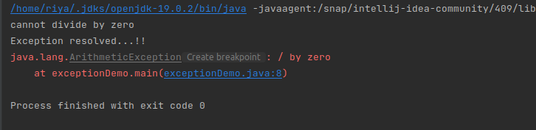

Ques 3: WAP to produce NoClassDefFoundError and ClassNotFoundException exception.

public class classNotFound

{

public static void main(String[] args)

{

try

{

Class.*forName*("class not exists..");

}

catch (ClassNotFoundException e)

{

e.printStackTrace();

}

finally {

System.*out*.println("class not found exception");

}

}

}

OUTPUT:

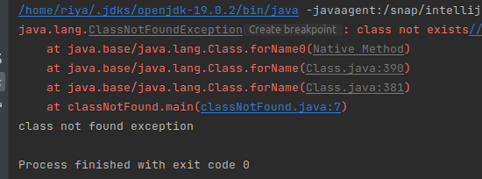

NoClassDefFoundError…>

public class classNotFound

{

public static void main(String[] args)

{

try

{

Class.*forName*("class not exists..");

}

catch (ClassNotFoundException e)

{

//e.printStackTrace();

System.*out*.println("class not found.........");

}

try{

throw new NoClassDefFoundError();

}

catch(NoClassDefFoundError e)

{

System.*out*.println("No class deFound error.....");

}

finally {

System.*out*.println("class not found exception");

}

}

}

OUTPUT:

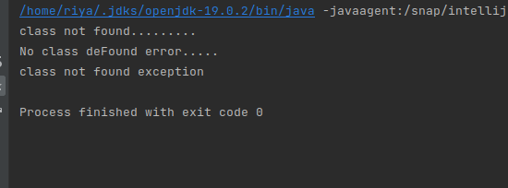

Ques 4: Customized Exception:

public class ques3

{

//Ques 4: custom exception

public static void chkAge(int age) throws ArithmeticException

{

if(age > 20)

{

System.*out*.println("access granted");

}

else {

throw new ArithmeticException("throw new arithmetic exception");

}

}

public static void main(String[] args)

{

try

{

*chkAge*(10);

}

catch(ArithmeticException e)

{

System.*out*.println(e);

}

finally {

System.*out*.println("rest of the code");

}

}

}

OUTPUT:

